**La première guerre mondiale**

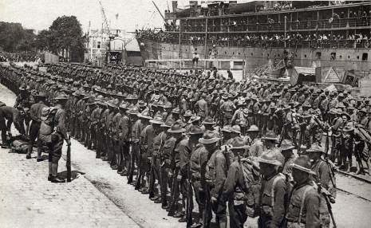

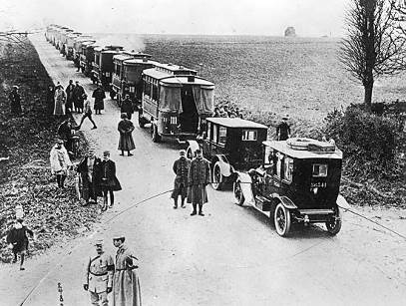



Entrée en guerre des États-Unis

**avril 1917**

Bataille de la Marne

**septembre 1914**

Assassinat de l’archiduc d’Autriche

**juin 1914**

|  |  |  |  |  |  |  |  |  |  |  |  |  |  |  |  |  |  |  |  |  |  |  |  |  |  |  |  |  |  |  |  |  |  |  |  |  |  |  |  |
| --- | --- | --- | --- | --- | --- | --- | --- | --- | --- | --- | --- | --- | --- | --- | --- | --- | --- | --- | --- | --- | --- | --- | --- | --- | --- | --- | --- | --- | --- | --- | --- | --- | --- | --- | --- | --- | --- | --- | --- |
|  |  |  |  |  |  |  |  |  |  |  |  |  |  |  |  |  |  |  |  |  |  |  |  |  |  |  |  |  |  |  |  |  |  |  |  |  |  |  |  |
|  |  |  |  |  |  |  |  |  |  |  |  |  |  |  |  |  |  |  |  |  |  |  |  |  |  |  |  |  |  |  |  |  |  |  |  |  |  |  |  |
|  |  |  |  |  |  |  |  |  |  |  |  |  |  |  |  |  |  |  |  |  |  |  |  |  |  |  |  |  |  |  |  |  |  |  |  |  |  |  |  |
|  |  |  |  |  |  |  |  |  |  |  |  |  |  |  |  |  |  |  |  |  |  |  |  |  |  |  |  |  |  |  |  |  |  |  |  |  |  |  |  |
|  | **1914** | |  |  |  |  | **1915** | |  |  |  |  | **1916** | |  |  |  |  | **1917** | |  |  |  | **1918** | |  |  |  |  | **1919** | |  |  |  |  | **1920** | |  |  |

**Première guerre mondiale (1914 / 1918)**

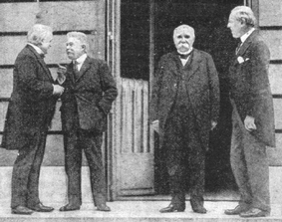

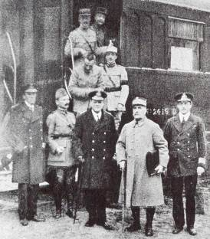

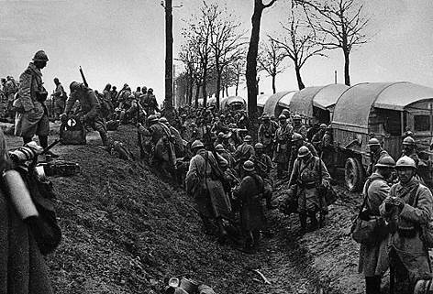

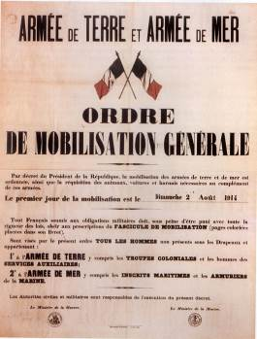

Traité de Versailles

**juin 1919**

Armistice

**11 novembre 1918**

Bataille de Verdun

**1916**

Entrée en guerre de la France

**août 1914**

